CS 305 Project One Template

Document Revision History

Version | Date | Author | Comments
1.0 | November 16, 2025 | Cristiano Miranda | Filled out the document based on the client’s information and their application’s code.

Client



Instructions
Submit this completed vulnerability assessment report. Replace the bracketed text with the relevant information. In this report, identify your security vulnerability findings and recommend the next steps to remedy the issues you have found.

- Respond to the five steps outlined below and include your findings.
- Respond using your own words. You may also include images or supporting materials. If you include them, make certain to insert them in the relevant locations in the document.
- Refer to the Project One Guidelines and Rubric for more detailed instructions about each section of the template.

Developer
Cristiano Miranda

1. Interpreting Client Needs
Determine your client’s needs and potential threats and attacks associated with the company’s application and software security requirements. Consider the following questions regarding how companies protect against external threats based on the scenario information:

- What is the value of secure communications to the company?
- Are there any international transactions that the company produces?
- Are there governmental restrictions on secure communications to consider?
- What external threats might be present now and in the immediate future?
- What modernization requirements must be considered, such as the role of open-source libraries and evolving web application technologies?

Based on the client's information and their current codebase, the client is requesting an application that securely handles the transfer and storage of sensitive user data and financial transactions. The clients' primary concern is protecting their organization from external threats. Their use of a RESTful API for their system indicates their primary concern is securing their application's communication with it, ensuring no vulnerabilities in the API or the application that could expose user data or compromise their financial transactions. Considering that Artemis Financial operates in the United States of America, it is allowed to facilitate international transactions for its users. Additionally, the client must comply with specific government regulations to secure communications. Thus, the client will be required to implement security measures to ensure their users are protected when utilizing their system, and these measures include tasks such as encrypting data and properly monitoring for potential intrusions, as these measures ensure that proper steps are taken to secure user data or to handle any breaches of data if an event occurs. These measures highlight the major threats hackers can pose to the client, including intercepting data or accessing the system to perform malicious actions. For example, hackers will attempt to intercept data sent from users to the server or vice versa to steal sensitive data. To prevent this attack, encryption and a secure connection between the server and users' clients will help ensure that hackers cannot intercept data, or, if they do, the data will be encrypted and still secure. Unauthorized access to the server can create multiple issues, such as hackers stealing sensitive data or entering malicious data into the system. Both instances can compromise the system and user data, so properly securing the server and restricting access to authorized users only is necessary to prevent this issue. Modernizing the client's current system and application can help with this issue and potentially prevent future problems from occurring by having their application utilize open-source libraries that are constantly updated to make fixing future vulnerabilities easier, since instead of having to alter the application's code to remove vulnerabilities, simply updating an open-source library would be required.

2. Areas of Security
Refer to the vulnerability assessment process flow diagram. Identify which areas of security apply to Artemis Financial’s software application. Justify your reasoning for why each area is relevant to the software application.

Based on the information gathered by reviewing the application's code and the information provided by Artemis Financial, the security areas that need to be addressed for this application are Input Validation, APIs, Cryptography, Client/Server, Coding Quality, and Coding Errors. To start, the application will use user input in some of its HTTPS request endpoints, and this input must be filtered and validated to prevent malicious data from being sent. Regarding API security, the clients already use a RESTful web application programming interface for their current operations, so implementing the API into the application must be done securely to avoid compromising the API on which their operations rely. It is essential to ensure that the API is integrated correctly into the application, that any interactions with it are monitored, and that any input sent to the API is validated beforehand. The application will handle sensitive actions and user data by sending requests that include this information, making encryption an important security measure to protect it and prevent hackers from stealing it. Additionally, the application uses a server/client architecture, so properly implementing security for both the client and the server is necessary to ensure that both the server and users are protected. If one system becomes vulnerable, it can compromise the other and potentially expose the entire application to malicious users. Code errors are another important security area for the application, since failure to handle errors or issues that occur can inadvertently expose how certain operations occur within the application. Considering that the application performs multiple actions and tasks, the risk of errors is high, and the information it might expose could compromise user security. Finally, Code Quality is another important aspect of the application, as properly implementing certain features and patterns is essential to ensuring it effectively prevents attacks and provides the necessary information to respond to them. For instance, the application should be coded with proper patterns that prevent potential vulnerabilities, and it should include appropriate processes so that, if attacks occur, they can be detected and addressed. In the end, identifying all security areas associated with the application's function is vital to ensuring they are correctly implemented so that potential vulnerabilities are addressed.

3. Manual Review
Continue working through the vulnerability assessment process flow diagram. Identify all vulnerabilities in the code base by manually inspecting the code.

Upon reviewing the code, multiple issues created vulnerabilities that hackers could exploit to access the system and its sensitive information.

Potential Vulnerabilities:
- Proper authorization controls are not implemented for the HTTPS request endpoints, so they are exposed to the public without authorization.
  - Without authorization checks, anyone who navigates to these endpoints can freely run, send, and receive data processed or generated by them, thereby compromising user and application security.
- No logging of any HTTPS request endpoint or server action is performed.
  - In the event an attack occurs or a malicious user attempts to attack the server, there is no way to know when the attack occurred. Additionally, if the attack were successful, there would be no data available on the attack or on how it occurred, making it nearly impossible to discover and debug the vulnerability that enabled it.
- In the CRUDController and GreetingController HTTPS request endpoints, User Input is not filtered.
  - Allowing any data to be accepted and processed by the server could allow malicious users to send malicious data in requests and compromise users' or the application's data.
- In the CRUDController and GreetingController HTTPS request endpoints, they use request parameters to store sensitive user data, such as the user's name or a business name for the financial information they are attempting to access.
  - Storing data in the request's parameters increases the likelihood that unauthorized users will steal it. Sending sensitive data in this manner is not ideal, as it can be easily read by hackers who could then use the information to compromise users.
- No error handling is present within the application.
  - Failure to implement proper error handling could expose users to detailed error messages that reveal important information, such as how the server functions and exactly what caused the issue. While most users might not understand or care about this information, hackers could use it to identify vulnerabilities within the application and deliberately create issues to understand how it functions and find ways to attack it more effectively.
- Multiple dependencies are outdated and house multiple vulnerabilities.
  - Over 13 dependencies were reported to have vulnerabilities, and these 13 dependencies exposed 158 vulnerabilities in the application. Having this many potential vulnerabilities for hackers to exploit is significantly problematic, as they can leverage public knowledge of these vulnerabilities in outdated dependencies to easily attack or compromise the system.
- No encryption is present in the application, specifically in the customer class.
  - A lack of encryption across all parts of the application can allow hackers to intercept data sent from the user to the server or vice versa, and to freely read and use the information they find. One area where this can compromise sensitive user data is the customer class, as the objects instantiated by this class will contain information about the user's financial data, such as their account number and balance. Without encrypting this data, if a hacker intercepts it or gains access to the system, the data becomes compromised and puts users' financial data at risk.

4. Static Testing
Run a dependency check on Artemis Financial’s software application to identify all security vulnerabilities in the code. Record the output from the dependency-check report. Include the following items:

- The names or vulnerability codes of the known vulnerabilities
- A brief description and recommended solutions provided by the dependency-check report
- Any attribution that documents how this vulnerability has been identified or documented previously

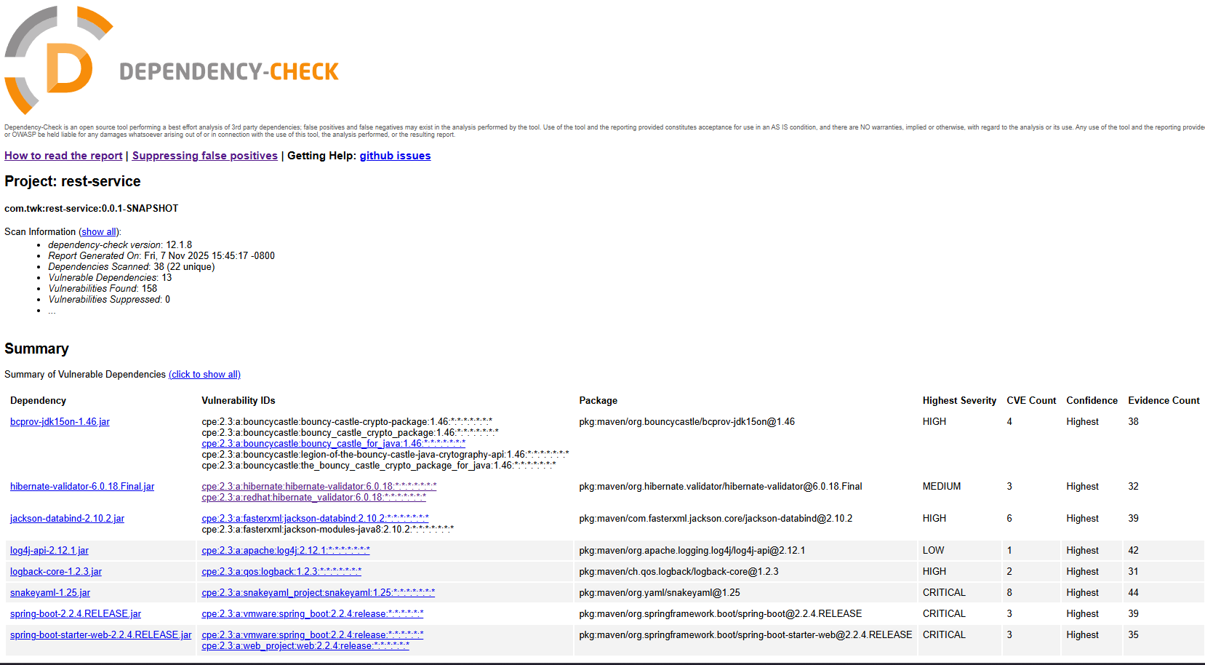
Running the dependency-check resulted in a report that details that over 13 vulnerable dependencies were discovered that these dependencies are causing 158 vulnerabilities to be present within the application.

These dependencies and the vulnerabilities they cause are as follows:
Name | Description | CVE Count | CVE Code(s) | Evidence Count | Solution
bcprov-jdk15on-1.46.jar | Java implementation of cryptographic algorithms | 4 |  | 38 | Update to latest version.
hibernate-validator-6.0.18.Final.jar | Hibernate's Bean Validation (JSR-380) reference implementation. | 3 | CVE-2025-35036  CVE-2023-1932  CVE-2020-10693 | 32 | Update to latest version.
jackson-databind-2.10.2.jar | General data-binding functionality for Jackson: works on core streaming API | 6 | CVE-2020-25649  CVE-2020-36518  CVE-2021-46877  CVE-2022-42003  CVE-2022-42004  CVE-2023-35116 | 39 | Update to latest version.
log4j-api-2.12.1.jar | The Apache Log4j API | 1 | CVE-2020-9488 | 42 | Update to latest version.
logback-core-1.2.3.jar | logback-core module | 2 | CVE-2023-6378  CVE-2021-42550 | 31 | Update to latest version.
snakeyaml-1.25.jar | YAML 1.1 parser and emitter for Java | 8 | CVE-2022-1471  CVE-2017-18640  CVE-2022-25857  CVE-2022-38749  CVE-2022-38751  CVE-2022-38752  CVE-2022-41854  CVE-2022-38750 | 44 | Update to latest version.
spring-boot-2.2.4.RELEASE.jar | Spring Boot | 3 | CVE-2023-20873  CVE-2022-27772  CVE-2023-20883 | 39 | Update to latest version.
spring-boot-starter-web-2.2.4.RELEASE.jar | Starter for building web, including RESTful, applications using Spring MVC. Uses Tomcat as the default embedded container | 3 | CVE-2023-20873  CVE-2022-27772  CVE-2023-20883 | 35 | Update to latest version.
spring-core-5.2.3.RELEASE.jar | Spring Core | 12 | CVE-2022-22965  CVE-2024-22259  CVE-2021-22118  CVE-2020-5421  CVE-2022-22950  CVE-2022-22971  CVE-2023-20861  CVE-2023-20863  CVE-2022-22968  CVE-2022-22970  CVE-2021-22060  CVE-2021-22096 | 36 | Update to latest version.
spring-web-5.2.3.RELEASE.jar | Spring Web | 13 | CVE-2016-1000027  CVE-2022-22965  CVE-2024-22259  CVE-2021-22118  CVE-2020-5421  CVE-2022-22950  CVE-2022-22971  CVE-2023-20861  CVE-2023-20863  CVE-2022-22968  CVE-2022-22970  CVE-2021-22060  CVE-2021-22096 | 34 | Update to latest version.
spring-webmvc-5.2.3.RELEASE.jar | Spring Web MVC | 12 | CVE-2022-22965  CVE-2024-22259  CVE-2021-22118  CVE-2020-5421  CVE-2022-22950  CVE-2022-22971  CVE-2023-20861  CVE-2023-20863  CVE-2022-22968  CVE-2022-22970  CVE-2021-22060  CVE-2021-22096 | 36 | Update to latest version.
tomcat-embed-core-9.0.30.jar | Core Tomcat implementation | 45 | CVE-2020-1938  CVE-2024-50379  CVE-2024-52316  CVE-2024-56337  CVE-2025-24813  CVE-2025-31651  CVE-2025-49124  CVE-2020-11996  CVE-2020-13934  CVE-2020-13935  CVE-2020-17527  CVE-2021-25122  CVE-2021-41079  CVE-2022-29885  CVE-2022-42252  CVE-2023-44487  CVE-2023-46589  CVE-2024-24549  CVE-2024-34750  CVE-2024-38286  CVE-2025-48988  CVE-2025-48989  CVE-2025-49125  CVE-2025-52434  CVE-2025-52520  CVE-2025-53506  CVE-2025-46701  CVE-2020-9484  CVE-2021-25329  CVE-2021-30640  CVE-2025-55668  CVE-2024-23672  CVE-2022-34305  CVE-2023-41080  CVE-2021-24122  CVE-2021-33037  CVE-2023-42795  CVE-2023-45648  CVE-2024-21733  CVE-2024-54677  CVE-2019-17569  CVE-2020-1935  CVE-2020-13943  CVE-2023-28708  CVE-2021-43980 | 30 | Update to latest version.
tomcat-embed-websocket-9.0.30.jar | Core Tomcat implementation | 46 | CVE-2020-1938  CVE-2024-50379  CVE-2024-52316  CVE-2024-56337  CVE-2025-24813  CVE-2025-31651  CVE-2025-49124  CVE-2020-8022  CVE-2020-11996  CVE-2020-13934  CVE-2020-13935  CVE-2020-17527  CVE-2021-25122  CVE-2021-41079  CVE-2022-29885  CVE-2022-42252  CVE-2023-44487  CVE-2023-46589  CVE-2024-24549  CVE-2024-34750  CVE-2024-38286  CVE-2025-48988  CVE-2025-48989  CVE-2025-49125  CVE-2025-52434  CVE-2025-52520  CVE-2025-53506  CVE-2025-46701  CVE-2020-9484  CVE-2021-25329  CVE-2021-30640  CVE-2025-55668  CVE-2024-23672  CVE-2022-34305  CVE-2023-41080  CVE-2021-24122  CVE-2021-33037  CVE-2023-42795  CVE-2023-45648  CVE-2024-21733  CVE-2024-54677  CVE-2019-17569  CVE-2020-1935  CVE-2020-13943  CVE-2023-28708  CVE-2021-43980 | 30 | Update to latest version.

Given the plethora of CVEs for each of the dependencies listed above, many issues need to be addressed to ensure the application runs without risking user data or the application itself. All issues found by the dependency checker can be resolved by simply updating dependencies to their latest versions. Doing so will eliminate all discovered code vulnerabilities caused by the out-of-date dependencies.

5. Mitigation Plan
Interpret the results from the manual review and static testing report. Then identify the steps to mitigate the identified security vulnerabilities for Artemis Financial’s software application.

Based on the information gathered from reviewing the codebase and performing the dependency check, specific steps and processes need to be implemented to reduce the number of vulnerabilities in the application and add additional security layers to further decrease the likelihood that a hacker can access the application. Regarding the added security layers, certain security features should be implemented in the application before developing new features, to ensure the current features are secure and do not house any vulnerabilities. These new security features must include logging all HTTPS request access, adding authorization to all HTTPS request endpoints, encrypting data sent to and from all HTTPS request endpoints, and changing how clients transfer data to the server. For the latter, user input data needs to be sent in the HTTPS request body to avoid exposing sensitive user data in the request URL. While hackers can easily intercept and access data stored in request parameters, the body of a user's HTTPS request can protect and secure it, making it harder for hackers to intercept and access the data. Additionally, to further increase the safety of data in transit, it needs to be encrypted before being transferred to or from the server, and decrypted once it arrives at its destination. Switching to this method would require additional processing time and power. However, it ensures that, if hackers intercept data, it is encrypted and protected, reducing the chance that hackers can access and use it. Further protection of the HTTPS request endpoints is another important factor that needs to be addressed. Even though some HTTPS request endpoints are open to the public and can be used by anyone, they still need to have authorization in place that specifies the required role level to access them. Implementing this change ensures that, going forward, all endpoints are appropriately locked to their role requirements, so that unauthorized users cannot compromise the system by accessing these sensitive HTTPS endpoints. Finally, the last additional security layer that needs to be added is activity logging. Specifically, logging should be performed whenever a user attempts to access an HTTPS request endpoint to provide the client with insight into who is accessing their system in the event of an attack. Having this information can help determine how a hacker gained access to the system and allow developers to patch the issue so it is prevented in the future. Still, the most important step is updating all dependencies to patch all known vulnerabilities in their older versions. Even if the updates require changes to the code base, the time spent doing so will be worth it, since multiple vulnerabilities have been found in the current code base due to outdated dependencies. Going forward, checking for dependency updates must be incorporated into the regular schedule to avoid this issue from occurring again and to ensure that known vulnerabilities identified by dependency developers are fixed and do not become potential vulnerabilities within the application that hackers can exploit to gain access.

